**Hruska’s Kolaches Ingredient Information Page**

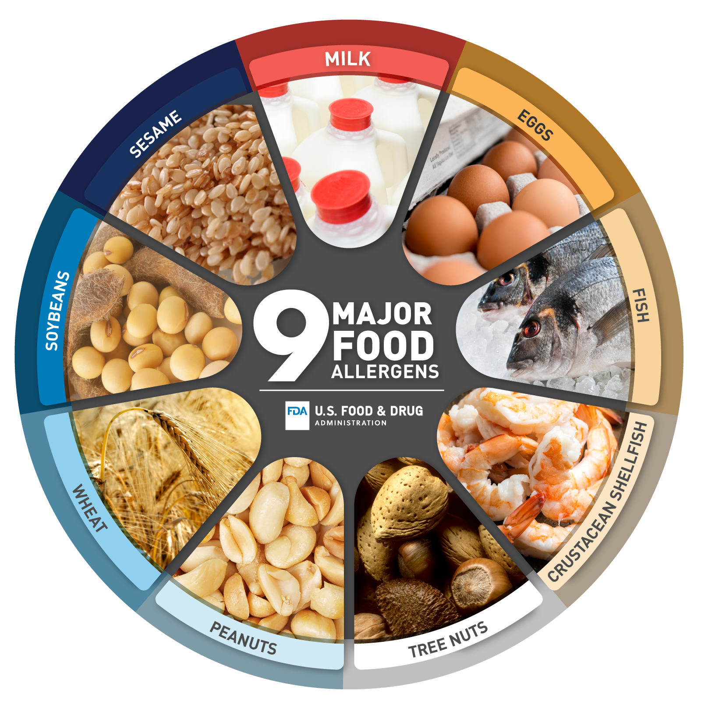

All Kolaches are produced in a facility that uses milk, wheat, egg, soy, and tree nuts.

All Kolaches are made using Kolache dough.

**Kolache Dough Ingredients:**

Milk

Margarine

Butter

Flour

Sugar

Egg Yolk

Salt

Contains: Milk, Wheat, Egg, Soy

**Savory Fillings listed in alphabetical order:**

**Bacon Egg and Cheese**

Filling ingredients: Bacon, Eggs, Cheddar Cheese, Onion, Salt, Pepper

Contains: Milk, Egg

**Bacon Egg Cheese and Jalapeño**

Filling ingredients: Bacon, Eggs, Cheddar Cheese, Jalapeños, Onion, Salt, Pepper

Contains: Milk, Egg

**Carnitas**

Filling Ingredients: House Pork, Cream, Lime, Garlic, Cilantro, Tomatoes, Avocado, Salt, Pepper

Contains: Milk, Egg

**Chicken Cilantro**

Filling ingredients: Grilled Chicken, Eggs, Cheddar Cheese, Red Onion, Poblano Peppers, Cilantro, Salt, Pepper, Garlic, Canola Oil

Contains: Milk, Egg

**Egg and Cheese**

Filling ingredients: Eggs, Cream Cheese, Cheddar Cheese, Onion Powder, Garlic Powder, Salt, Pepper

Contains: Milk, Egg

**Ham Egg and Cheese**

Filling ingredients: Ham, Eggs, Cheddar Cheese, Onion, Salt, Pepper, Canola Oil

Contains: Milk, Egg

**Mexican Omelet**

Filling Ingredients: Eggs, Red Onion, Poblano Peppers, Tomatillos, Tomatoes, Avocados, Cilantro, Garlic, Salt, Pepper, Canola Oil

Contains: Egg

**Pulled Pork**

Filling Ingredients: House Pork, Orange Juice, Garlic, Salt, Pepper, Red Pepper, Beef Base, Vinegar, Onion Powder, Orange Marmalade

**Ranchero**

Filling Ingredients: Eggs, Bell Peppers, Jalapeños, Onion, Garlic, Salt, Pepper, Canola Oil

Contains: Egg

**Sausage Egg and Cheese**

Filling ingredients: House Sausage, Eggs, Cheddar Cheese, Onion, Salt, Pepper, Canola Oil

Contains: Milk, Egg

**Sausage Egg Cheese and Jalapeño**

Filling ingredients: House Sausage, Eggs, Cheddar Cheese, Jalapeños, Onion, Salt, Pepper, Canola Oil

Contains: Milk, Egg

**Sausage and Gravy**

Filling ingredients: House Sausage, Milk, Flour, Salt, Pepper, Canola Oil

Contains: Milk, Wheat

**Texas Style**

Filling Ingredients: Beef Polish Dog, Cheddar Cheese, Jalapeños

Contains: Milk

**Sweet Fillings listed in alphabetical order:**

**Blackberry and Cream**

Filling Ingredients: House Blackberry Compote, House Cream Cheese Filling

Contains: Milk, Egg

**Blueberry and Cream**

Filling Ingredients: House Blueberry Compote, House Cream Cheese Filling

Contains: Milk, Egg

**Cherry and Cream**

Filling Ingredients: House Cherry Compote, House Cream Cheese Filling

Contains: Milk, Egg

**Cinnamon**

Filling Ingredients: House Cream Cheese Filling, Cinnamon, Sugar, Margarine

Contains: Milk, Egg, Soy

**Cream Cheese Plain**

Filling Ingredients: House Cream Cheese Filling

Contains: Milk, Egg

**Fruit Plain**

Filling Ingredients: House Fruit Compote

**Maple Pecan**

Filling Ingredients: House Maple Filling, Brown Sugar, Pecans

Contains: Milk, Egg, Tree Nuts

**Mixed Berry**

Filling Ingredients: House Blueberry Compote, House Strawberry Compote, House Cream Cheese Filling

Contains: Milk, Egg

**Peach and Cream**

Filling Ingredients: House Peach Compote, House Cream Cheese Filling

Contains: Milk, Egg

**Strawberry and Cream**

Filling Ingredients: House Strawberry Compote, House Cream Cheese Filling

Contains: Milk, Egg

**Strawberry Nutella**

Filling Ingredients: House Strawberry Compote, House Hazelnut Nutella Filling

Contains: Milk, Egg, Tree Nuts

**Raspberry and Cream**

Filling Ingredients: House Raspberry Compote, House Cream Cheese Filling

Contains: Milk, Egg

**\*\*House Fillings\***

**House Cream Cheese Filling**

Filling Ingredients: Cream Cheese, Cottage Cheese, Sugar, Egg

Contains: Milk, Egg

**House Fruit Compotes**

Filling Ingredients: Fruit, Fruit Concentrates, Sugar, Clearjel modified cornstarch

**House Sausage**

Ingredients: Pork, Beef, Onion Powder, Garlic Powder, Salt, Pepper, Sage

**Kolache Filling Quick Guide**

**Vegetarian-** Mexican Omelet, Egg and Cheese, Ranchero, All Sweet Fillings

**Dairy Free-** Mexican Omelet, Ranchero, Pulled Pork, Plain Fruit Sweet Filling

**Egg Free-** Texas Style, Sausage and Gravy, Pulled Pork, Carnitas, Plain Fruit Sweet Filling